# Corporate Chart Prototype

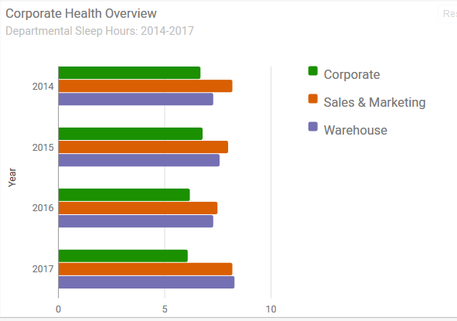

This is an example for a corporate chart, I think it works well if it is kept simple (a bar chart or histogram are probably the leading options).

Colours are entirely customisable.

Code has been copy/pasted below and is ready to be pasted into the html, obviously the js files need to be downloaded and included.

# HTML

<script type="text/javascript" src="https://www.google.com/jsapi?autoload={'modules':[{'name':'visualization','version':'1.1','packages':['bar']}]}"></script>

<div id="chart_div"></div>

<br/>

<div id="btn-group">

<button class="button button-blue" id="none">No Format</button>

<button class="button button-blue" id="scientific">Scientific Notation</button>

<button class="button button-blue" id="decimal">Decimal</button>

<button class="button button-blue" id="short">Short</button>

</div>

# Google Chart Code (JS tested on JSFIDDLE)

google.setOnLoadCallback(drawChart);

function drawChart() {

var data = google.visualization.arrayToDataTable([

['Year', 'Corporate', 'Sales & Marketing', 'Warehouse'],

['2014', 6.7, 8.2, 7.3],

['2015', 6.8, 8.0, 7.6],

['2016', 6.2, 7.5, 7.3],

['2017', 6.1, 8.2, 8.3]

]);

var options = {

chart: {

title: 'Corporate Health Overview',

subtitle: 'Departmental Sleep Hours: 2014-2017',

},

bars: 'horizontal', // Required for Material Bar Charts.

hAxis: {format: 'decimal'},

height: 400,

colors: ['#1b9000', '#d95f02', '#7570b3']

};

var chart = new google.charts.Bar(document.getElementById('chart_div'));

chart.draw(data, google.charts.Bar.convertOptions(options));

var btns = document.getElementById('btn-group');

btns.onclick = function (e) {

if (e.target.tagName === 'BUTTON') {

options.hAxis.format = e.target.id === 'none' ? '' : e.target.id;

chart.draw(data, google.charts.Bar.convertOptions(options));

}

}

}